Exercise 1: Configuring a Basic Spring Application
BookRepository.java:
package com.example.repository;

public class BookRepository {

public void displayRepositoryMessage() {
System.out.println("Book Repository Bean Created");
}
}

BookService.java:
package com.example.service;

public class BookService {

public void displayServiceMessage() {
System.out.println("Book Service Bean Created");
}
}

App.java:
package com.example;

import org.springframework.context.ApplicationContext;
import org.springframework.context.support.ClassPathXmlApplicationContext;

import com.example.repository.BookRepository;
import com.example.service.BookService;

public class App {

public static void main(String[] args) {

ApplicationContext context =
new ClassPathXmlApplicationContext("applicationContext.xml");

BookService service =
context.getBean("bookService", BookService.class);

BookRepository repository =
context.getBean("bookRepository", BookRepository.class);

service.displayServiceMessage();
repository.displayRepositoryMessage();
}
}

applicationContext.xml:
<?xml version="1.0" encoding="UTF-8"?>

<beans xmlns="http://www.springframework.org/schema/beans"
xmlns:xsi="http://www.w3.org/2001/XMLSchema-instance"
xsi:schemaLocation="
http://www.springframework.org/schema/beans
https://www.springframework.org/schema/beans/spring-beans.xsd">

<!-- BookService Bean -->
<bean id="bookService"
class="com.example.service.BookService"/>

<!-- BookRepository Bean -->
<bean id="bookRepository"
class="com.example.repository.BookRepository"/>

</beans>

Pom.xml:
<project xmlns="http://maven.apache.org/POM/4.0.0"
xmlns:xsi="http://www.w3.org/2001/XMLSchema-instance"
xsi:schemaLocation="http://maven.apache.org/POM/4.0.0
https://maven.apache.org/xsd/maven-4.0.0.xsd">

<modelVersion>4.0.0</modelVersion>

<groupId>com.example</groupId>
<artifactId>demo</artifactId>
<version>1.0-SNAPSHOT</version>

<properties>
<maven.compiler.source>17</maven.compiler.source>
<maven.compiler.target>17</maven.compiler.target>
</properties>

<dependencies>

<dependency>
<groupId>org.springframework</groupId>
<artifactId>spring-context</artifactId>
<version>6.2.8</version>
</dependency>

</dependencies>

</project>

Output:
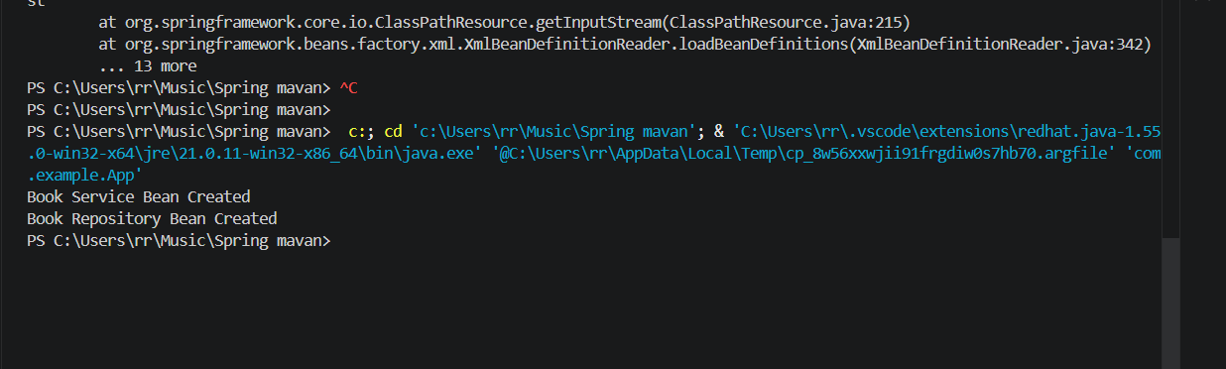

Exercise 2: Implementing Dependency Injection
BookRepository.java:
package com.example.repository;

public class BookRepository {

public void getBook() {
System.out.println("Getting book details from repository...");
}
}

BookService.java:
package com.example.service;

import com.example.repository.BookRepository;

public class BookService {

private BookRepository bookRepository;

// Setter Injection
public void setBookRepository(BookRepository bookRepository) {
this.bookRepository = bookRepository;
}

public void displayBook() {
System.out.println("Book Service is using Book Repository");
bookRepository.getBook();
}
}

applicationContext.xml:
<?xml version="1.0" encoding="UTF-8"?>

<beans xmlns="http://www.springframework.org/schema/beans"
xmlns:xsi="http://www.w3.org/2001/XMLSchema-instance"
xsi:schemaLocation="
http://www.springframework.org/schema/beans
https://www.springframework.org/schema/beans/spring-beans.xsd">

<!-- Repository Bean -->
<bean id="bookRepository"
class="com.example.repository.BookRepository"/>

<!-- Service Bean -->
<bean id="bookService"
class="com.example.service.BookService">

<!-- Dependency Injection -->
<property name="bookRepository" ref="bookRepository"/>

</bean>

</beans>

App.java:
package com.example;

import org.springframework.context.ApplicationContext;
import org.springframework.context.support.ClassPathXmlApplicationContext;

import com.example.service.BookService;

public class App {

public static void main(String[] args) {

ApplicationContext context =
new ClassPathXmlApplicationContext("applicationContext.xml");

BookService service =
context.getBean("bookService", BookService.class);

service.displayBook();
}
}

Output:
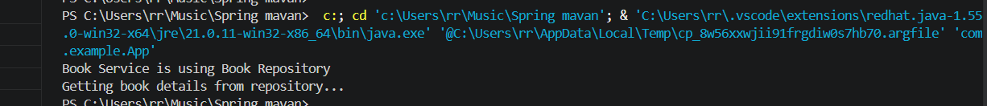
Exercise 4: Creating and Configuring a Maven Project
App.java:
package com.library;

public class App {
public static void main(String[] args) {
System.out.println("Spring Maven Project Configured Successfully");
}
}

Pom.xml:
<project xmlns="http://maven.apache.org/POM/4.0.0"
xmlns:xsi="http://www.w3.org/2001/XMLSchema-instance"
xsi:schemaLocation="http://maven.apache.org/POM/4.0.0
https://maven.apache.org/xsd/maven-4.0.0.xsd">

<modelVersion>4.0.0</modelVersion>

<groupId>com.library</groupId>
<artifactId>LibraryManagement</artifactId>
<version>1.0-SNAPSHOT</version>

<dependencies>

<dependency>
<groupId>org.springframework</groupId>
<artifactId>spring-context</artifactId>
<version>6.2.8</version>
</dependency>

<dependency>
<groupId>org.springframework</groupId>
<artifactId>spring-aop</artifactId>
<version>6.2.8</version>
</dependency>

<dependency>
<groupId>org.springframework</groupId>
<artifactId>spring-webmvc</artifactId>
<version>6.2.8</version>
</dependency>

</dependencies>

<build>
<plugins>
<plugin>
<groupId>org.apache.maven.plugins</groupId>
<artifactId>maven-compiler-plugin</artifactId>
<version>3.11.0</version>

<configuration>
<source>1.8</source>
<target>1.8</target>
</configuration>
</plugin>
</plugins>
</build>

</project>

Output:
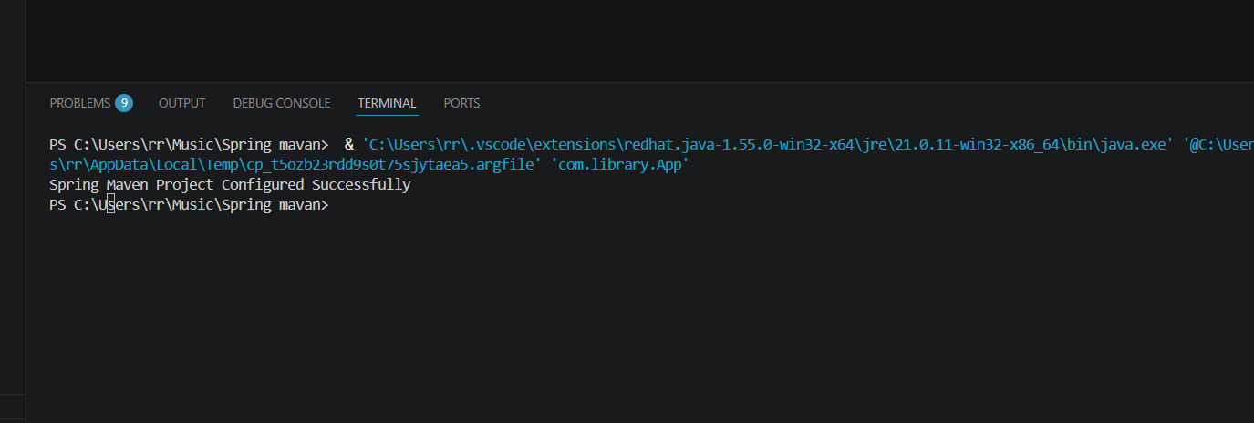

Exercise 5: Configuring the Spring IoC Container
BookRepository.java:
package com.library.repository;

public class BookRepository {

public void getBook() {
System.out.println("Book details fetched from repository");
}
}

BookService.java:
package com.library.service;

import com.library.repository.BookRepository;

public class BookService {

private BookRepository bookRepository;

public void setBookRepository(BookRepository bookRepository) {
this.bookRepository = bookRepository;
}

public void displayBook() {
System.out.println("Book Service is working");
bookRepository.getBook();
}
}

applicationContext.xml:
<?xml version="1.0" encoding="UTF-8"?>

<beans xmlns="http://www.springframework.org/schema/beans"
xmlns:xsi="http://www.w3.org/2001/XMLSchema-instance"
xsi:schemaLocation="
http://www.springframework.org/schema/beans
https://www.springframework.org/schema/beans/spring-beans.xsd">

<bean id="bookRepository"
class="com.library.repository.BookRepository"/>

<bean id="bookService"
class="com.library.service.BookService">

<property name="bookRepository"
ref="bookRepository"/>

</bean>

</beans>

App.java:
package com.library;

import org.springframework.context.ApplicationContext;
import org.springframework.context.support.ClassPathXmlApplicationContext;

import com.library.service.BookService;

public class App {

public static void main(String[] args) {

ApplicationContext context =
new ClassPathXmlApplicationContext("applicationContext.xml");

BookService service =
context.getBean("bookService", BookService.class);

service.displayBook();
}
}

Output:
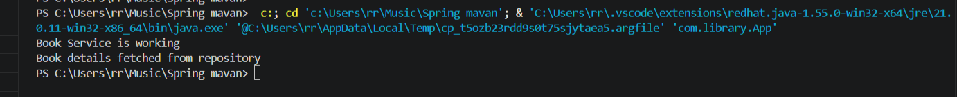

Exercise 7: Implementing Constructor and Setter Injection
BookRepository.java:
package com.library.repository;

public class BookRepository {

public void getBook() {
System.out.println("Book details fetched from repository");
}
}

BookService.java:
package com.library.service;

import com.library.repository.BookRepository;

public class BookService {

private BookRepository bookRepository;

// Constructor Injection
public BookService(BookRepository bookRepository) {
this.bookRepository = bookRepository;
System.out.println("Constructor Injection Executed");
}

// Setter Injection
public void setBookRepository(BookRepository bookRepository) {
this.bookRepository = bookRepository;
System.out.println("Setter Injection Executed");
}

public void displayBook() {
System.out.println("Book Service is working");
bookRepository.getBook();
}
}

applicationContext.xml:
<?xml version="1.0" encoding="UTF-8"?>

<beans xmlns="http://www.springframework.org/schema/beans"
xmlns:xsi="http://www.w3.org/2001/XMLSchema-instance"
xsi:schemaLocation="
http://www.springframework.org/schema/beans
https://www.springframework.org/schema/beans/spring-beans.xsd">

<!-- Repository Bean -->
<bean id="bookRepository"
class="com.library.repository.BookRepository"/>

<!-- Service Bean -->
<bean id="bookService"
class="com.library.service.BookService">

<!-- Constructor Injection -->
<constructor-arg ref="bookRepository"/>

<!-- Setter Injection -->
<property name="bookRepository"
ref="bookRepository"/>

</bean>

</beans>

App.java:
package com.library;

import org.springframework.context.ApplicationContext;
import org.springframework.context.support.ClassPathXmlApplicationContext;

import com.library.service.BookService;

public class App {

public static void main(String[] args) {

ApplicationContext context =
new ClassPathXmlApplicationContext("applicationContext.xml");

BookService service =
context.getBean("bookService", BookService.class);

service.displayBook();
}
}

Output:
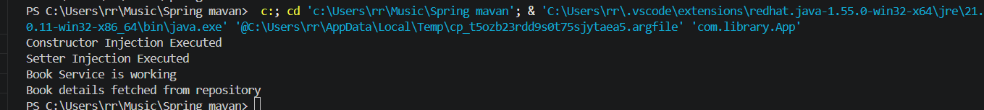

Exercise 9: Creating a Spring Boot Application
Controller.java:
package com.library.controller;

import java.util.List;

import org.springframework.beans.factory.annotation.Autowired;
import org.springframework.web.bind.annotation.*;

import com.library.entity.Book;
import com.library.repository.BookRepository;

@RestController
@RequestMapping("/books")
public class BookController {

@Autowired
private BookRepository repository;

@GetMapping
public List<Book> getBooks() {
return repository.findAll();
}

@PostMapping
public Book addBook(@RequestBody Book book) {
return repository.save(book);
}
}

Book.java:
package com.library.entity;

import jakarta.persistence.Entity;
import jakarta.persistence.Id;

@Entity
public class Book {

@Id
private int id;

private String title;

private String author;

public Book() {
}

public Book(int id, String title, String author) {
this.id = id;
this.title = title;
this.author = author;
}

public int getId() {
return id;
}

public void setId(int id) {
this.id = id;
}

public String getTitle() {
return title;
}

public void setTitle(String title) {
this.title = title;
}

public String getAuthor() {
return author;
}

public void setAuthor(String author) {
this.author = author;
}
}

LibrarymanagementApplication.java:
@SpringBootApplication
public class LibrarymanagementApplication {

public static void main(String[] args) {
SpringApplication.run(LibrarymanagementApplication.class, args);
}
}

BookRepository.java:
package com.library.repository;

import org.springframework.data.jpa.repository.JpaRepository;
import com.library.entity.Book;

public interface BookRepository
extends JpaRepository<Book, Integer> {

}

Output:
